ONLINE LEARNING AGREEMENT INSTRUCTION – OUTGOING STUDENTS (SHORT-TERM MOBILITY)

After the Erasmus+ Office assigns the mobility to your usos account and after creating the template of your LA by the Program Coordinator, you can start to fill in the Learning Agreement

STEP I – FILLING IN THE TABLE A AND B LEARNING AGREEMENT ONLINE

- Click on: STUDENT’S SECTION
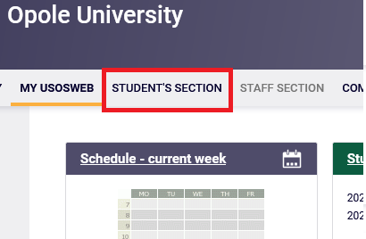

- Click on: Student Exchange

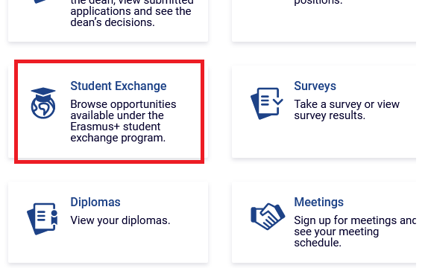

- Click on: mobilities
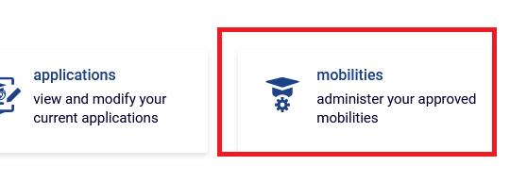
- Click on: EWP LA
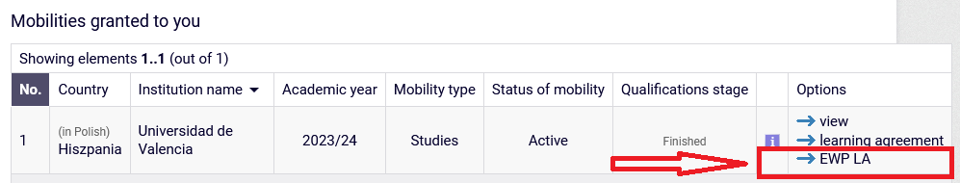

- Edit the visable data, if necessary e.g. dates of the mobility, coordinator details. Then click on: view/edit of the Learning Agreement (on the bottom of the page):
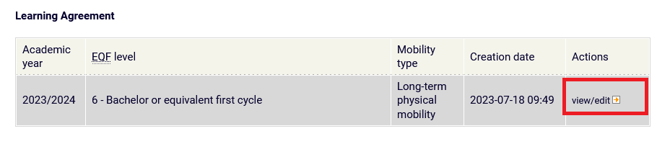
- From now on you will be able to see the template of the Learning Agreement, which you have to fill in with the components from your short-term mobility. To insert the component click on: „Add a component”

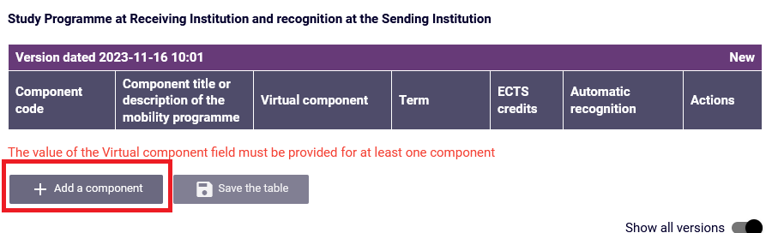

- Insert the information about phisical and virtual components and save inserted information:
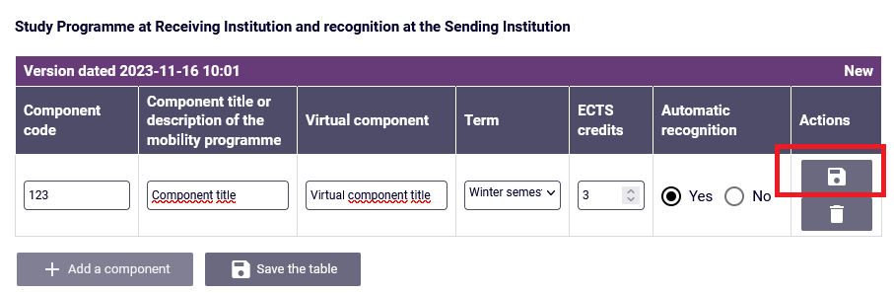
- After adding all the components click on „Approve”:

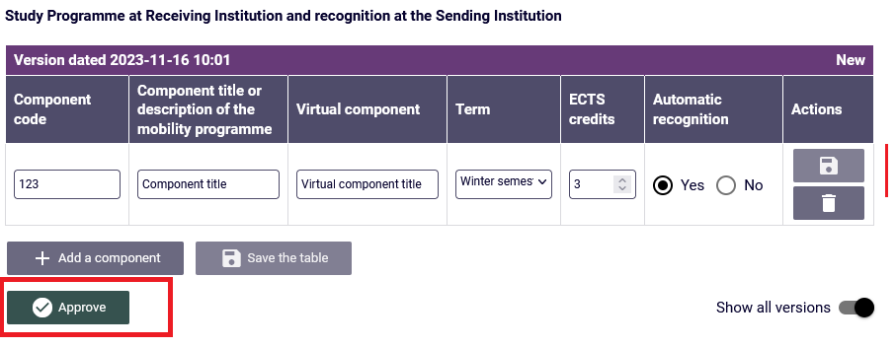

Right now the OLA approved by you will be send for the acceptance of the Program Coordinator at UO. Please contact your Program Coordinator and inform him/her that you prepared the LA and ask fot their acceptance.
After the Program Coordinator approves your LA, it will be automatically send for the acceptance of the Partner University. After the Partners University accepts LA, the document is completed.
(In case of adding any changes in the LA by the Program Coordinator the LA will come back to you for the approval again).

