ONLINE LEARNING AGREEMENT INSTRUCTION – OUTGOING STUDENTS

After the Erasmus+ Office assigns the mobility to your usos account and after creating the template of your LA by the Program Coordinator, you can start to fill in the Learning Agreement

STEP I – FILLING IN THE TABLE A AND B LEARNING AGREEMENT ONLINE

- Click on: STUDENT’S SECTION
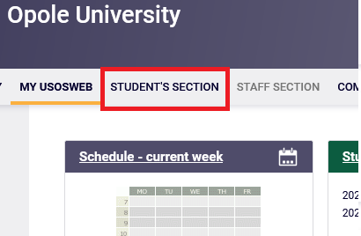

- Click on: Student Exchange

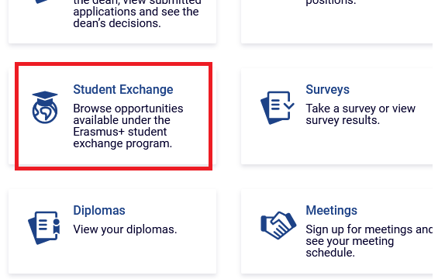

- Click on: mobilities
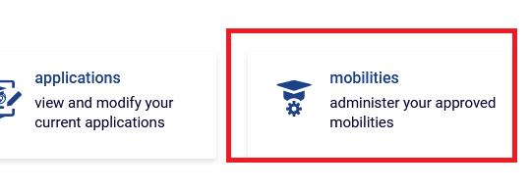
- Click on: EWP LA
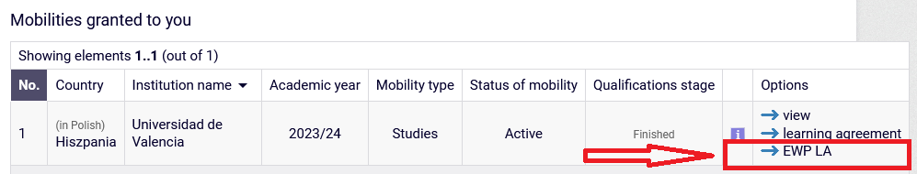

- Edit the visable data, if necessary e.g. dates of the mobility, coordinator details. Then click on: view/edit of the Learning Agreement (on the bottom of the page):
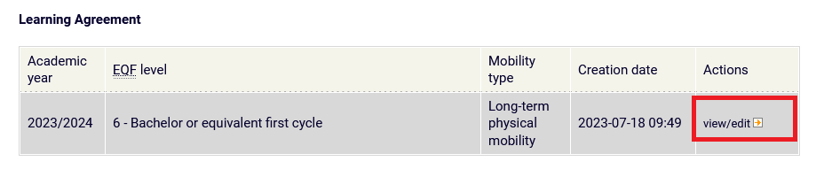
- From now on you will be able to see the template of the Learning Agreement, which you have to fill in. Just like in the paper version of LA, here, we also have the table A and B.

In the table A you have to add courses which you are planning to study abroad, in the partner University. In the table B you have to add the courses from UO, which are the equivalents of the courses planned to study abroad (the courses from UO which you will not have to „pass” after you return from your mobility, if you will pass all the courses form table A abroad).

All the courses you want to add to the table A and B you can add by clicking on: Add component
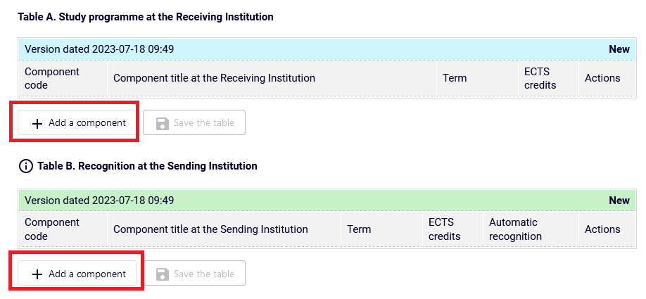
- You fill in all the details of the added courses in the table A and then you click on „Save” after inserting each of them
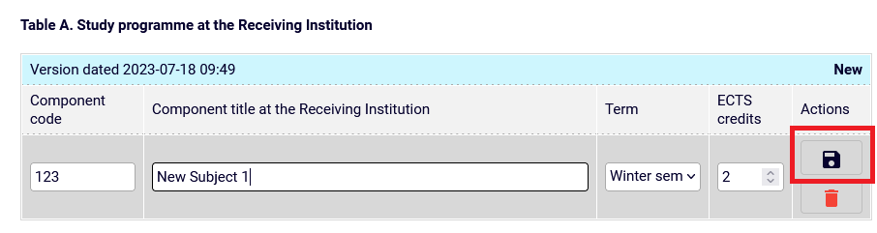
- After adding the last course in the table A you click on: Save the table
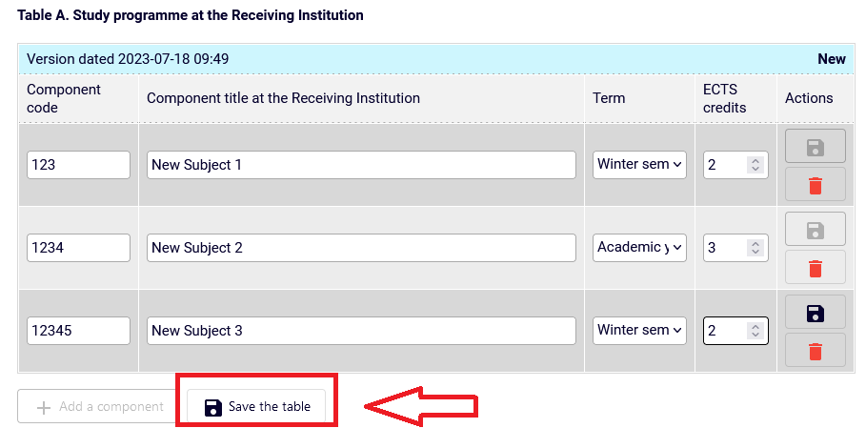
And right now the table A is completed.
- After adding all the courses in the table A you can start filling in the table B with the subjects form UO. Insert the course code of the subject you want to add in the table B and choose the right course.
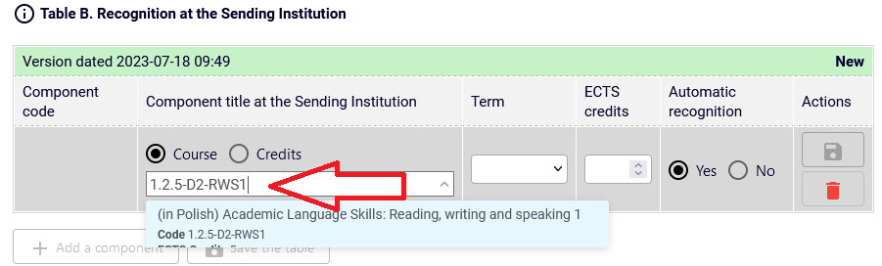
- After adding the right course in the table B you click on „Save”
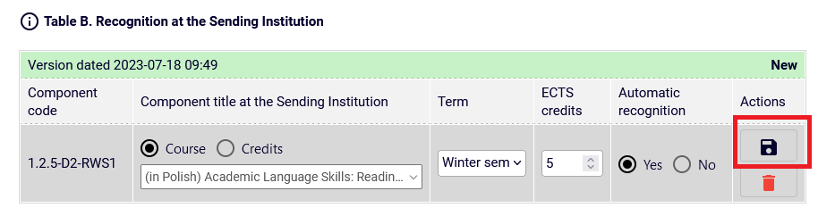
- After adding the last course in the table B you click on: Save the table
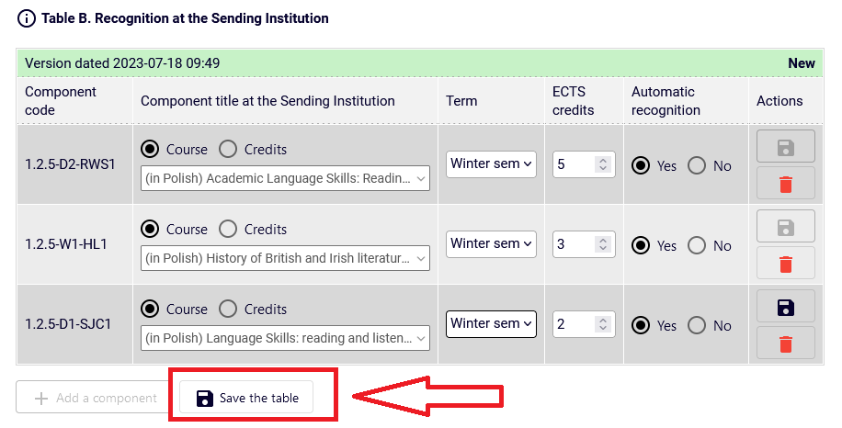
And right now the table B is completed.

- After filling in the table A and B you click on: Approve
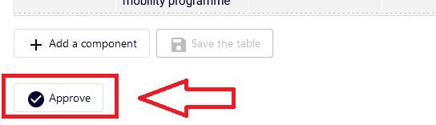

Right now the OLA approved by you will be send for the acceptance of the Program Coordinator at UO. After the Program Coordinator approves your LA, it will be automatically send for the acceptance of the Partner University. After the Partners University accepts LA, the document is completed.

(In case of adding any changes in the LA by the Program Coordinator the LA will come back to you for the approval again).

