ONLINE LEARNING AGREEMENT INSTRUCTION (DURING THE MOBILITY PART) FOR OUTGOING STUDENTS
STEP I – FILLING IN TABLES A2 AND B2 OF LEARNING AGREEMENT ONLINE

- Click on: STUDENT’S SECTION
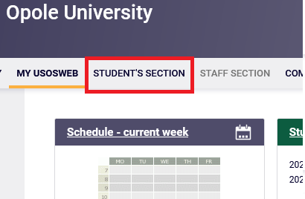

- Click on: Student Exchange

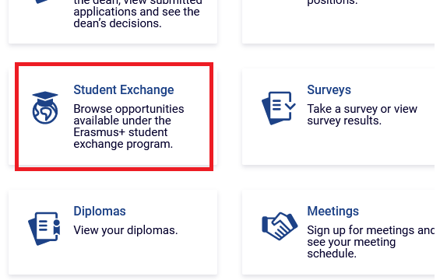
- Click on: mobilities
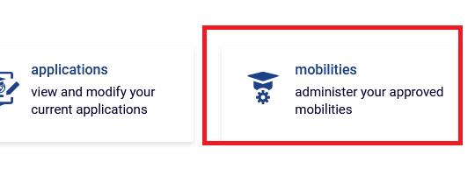
- Click on: EWP LA
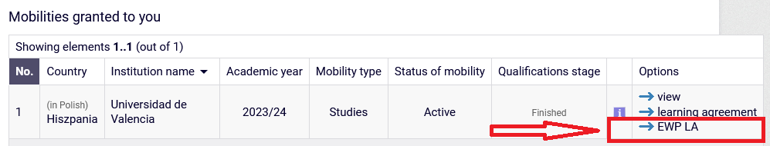

- Click on view/edit of the Learning Agreement (at the bottom of the page):
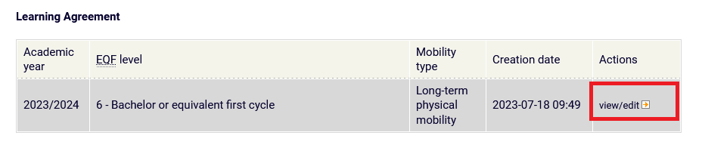
Now you will see the Learning Agreement before the mobility which you can modify by adding changes. To do that click on „Create a new version”:
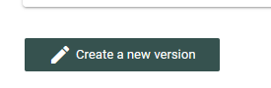

- Deleting the components from table A. Click on „delete” next to the subject you want to delete from LA:
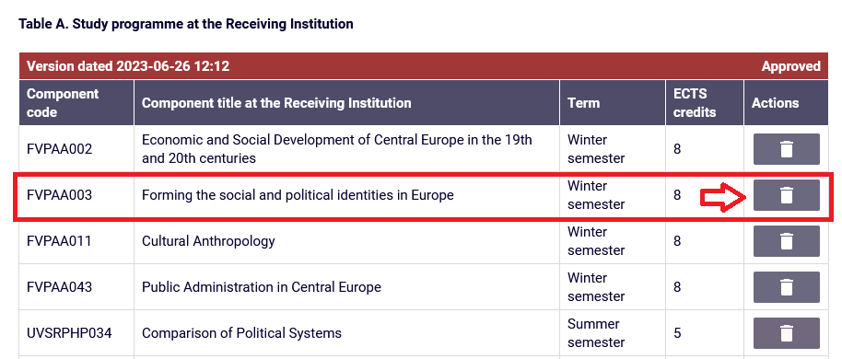

Now you will see the dedicated table where you should write the reason for the change. Fill lit in and click on „remove”
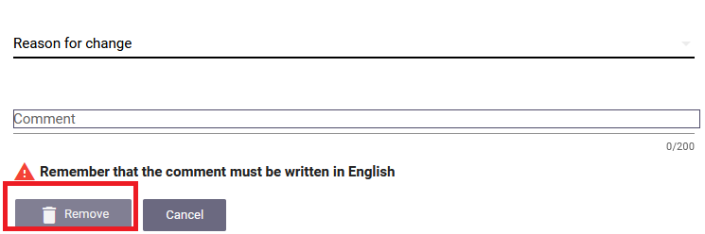

- After deleting all the components you wanted to delete from LA you can add new ones by clicking on „Add component”
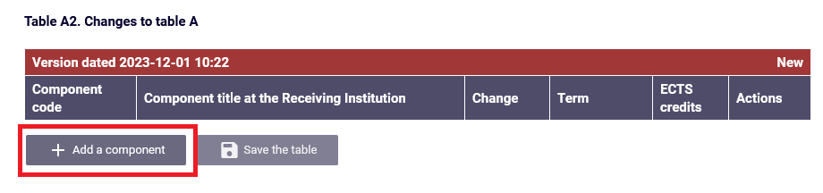

Now you will see the dedicated table where you should write the reason for the change. Fill lit in and click on „Add component”:
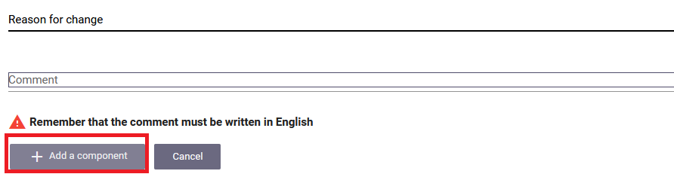

After adding the new component click on „save ”:
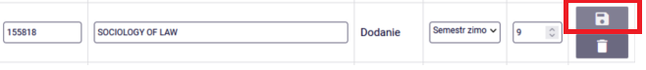

- After adding all the necessary new components click on „Save the table”:

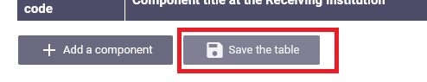
The same instruction is for deleting/adding courses in table B2, if there have to be included changes as well:

- Deleting a component from table B. Click on ”delete” next to the subject you want to delete from your LA:
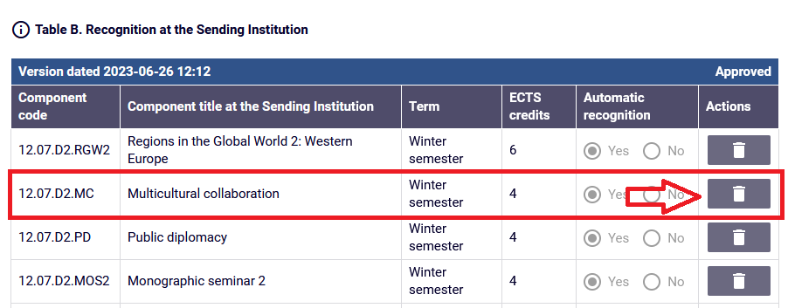

- After deleting all the components you wanted to delete from the table B of your LA you can add new ones by clicking on „Add a component”:
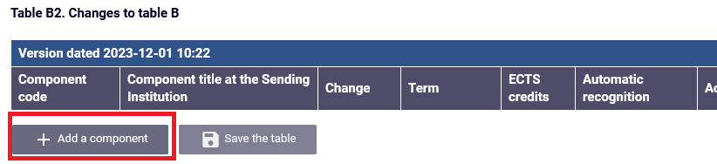

(after adding all the necessary subjects in the table B2 click on „save the table”)

- After you insert all the changes in the LA click on „Accept” (at the bottom of the page):

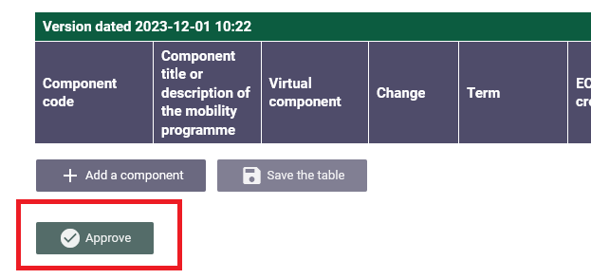

Now your accepted Learning Agreement during the mobility will be visible for your Program Coordinator. Ask your Program Coordinator for their acceptance. After the program Coordinator accepts the LA it will be automatically sent for the acceptance of the Partner University.

